**Online Blood Bank Management System through AWS Architecture**

Ayush Kumar Gupta, Sai Mani Ritish Upadhyayula, Vidhiben Ashokbhai Vanani and Teja Sree Kokkanti  
CS_519_01_IN:Cloud Computing Overview – SEATTLE – Fall 2024-2025  
School of Technology & Computing

City University of Seattle

Seattle, WA 98121, USA

guptaayushkumar@cityuniversity.edu, upadhyayulasaimanir@cityuniversity.edu, vananividhibenashok@cityuniversity.edu,   
[kokkantitejasree@cityuniversity.edu](mailto:kokkantitejasree@cityuniversity.edu)

**ABSTRACT**

With the objective of increasing the effectiveness and accessibility of blood donation and management, this research presents an online blood bank management system that leverages cloud computing. The system's web-based and mobile application capabilities allow users to register, search for donors, locate local blood banks, and track blood availability in real-time. The software facilitates seamless information flow by integrating donor, patient, and blood bank management perspectives. Users can securely log in to access the system, while the mobile app enables patients to locate and contact local donors using GPS in emergencies. Additionally, registered users receive timely alerts for health drives and blood donation camps.

Through cloud-based infrastructure, donor records, blood inventory, blood bank requirements, and blood bank lab temperature can all be monitored and accessed efficiently, minimizing operational delays, and reducing human error. The system’s inventory modules track blood stock levels, demand, and requests, supporting faster decision-making and enhanced collaboration among stakeholders in critical situations. The cloud’s real-time connectivity further improves response times in emergencies by reducing the distance between donors and blood banks. This technology addresses challenges such as blood shortages and inefficient manual processes, encouraging blood donations by streamlining the donor registration process and closing the gap between donors and blood banks. Cloud computing ensures that the system remains scalable, stable, and accessible from any device or location, establishing it as an essential tool for life-saving healthcare operations.

**Keywords:** Cloud Computing, Blood Bank Management, Real-Time Tracking, Inventory Management, Donor Coordination, Mobile Application

1. **INTRODUCTION**

In the medical field, easy and effective blood management is essential to protecting lives. To improve the success and accessibility of blood donation and management procedures, this study presents an exciting online blood bank management system that makes use of cloud computing. Users can register, look for donors, find local blood banks, and monitor blood supply in real-time using the system's web-based and mobile application features.

The platform integrates perspectives from blood bank administrators, donors, and patients to ensure a smooth flow of information. Users can register and access the system securely using login credentials. The mobile app employs GPS technology, allowing patients to quickly locate and contact nearby donors in emergency situations. Additionally, registered users are notified about upcoming health drives and blood donation camps.

The cloud-based infrastructure at the core of this solution facilitates centralized and efficient data management. By enabling quick access to donor records, blood inventory, blood bank requirements, and blood bank lab temperature monitoring, the system minimizes manual errors and operational delays. The inventory modules track requests, demand, and blood stock levels, allowing blood banks to respond promptly in urgent situations. With the cloud’s real-time connectivity, decision-making is accelerated, and stakeholder collaboration is improved during emergencies, effectively reducing the distance between donors and blood banks.

By improving the donor registration process, this approach not only encourages more people to donate blood but also targets common issues such as blood shortages and expensive manual processes. The method improves blood preservation, speeds up decision-making, and encourages more efficient resource management by establishing a connection between blood banks and donors. By ensuring the system's scalability, confidence, and accessibility from any device or location, cloud computing plays a major part in supporting this life-saving healthcare operation.

1. **LITERATURE REVIEW**

Blood management systems have become one of the most critical aspects of modern healthcare, ensuring that blood and its components are available and used efficiently while resolving issues with safety, wastage, and accessibility. The advantages and associated disadvantages of a blood management system.

**1. Advantages**

**1.Improved Traceability and Reporting:**

Currently, modern blood management systems use a coded tracking device on every unit, which begins with the blood donor and ends with the patient receiving the blood. The blood management system maintained these records as documents and claims for effective audits and resolving disputes. They also help in determining any errors or inefficiencies, enhancing overall operational efficiency [[1]](https://www.who.int/news-room/fact-sheets/detail/blood-safety-and-availability).

**2.Supports Emergency Preparedness:**

Blood management systems serve a purpose during the disaster which is made possible through the current updated inventory of resources and resource tracking across facilities. Improved technologies have the ability to monitor decisions in real time and make decisions when necessary, aiding in effective resource allocation in the event of a disaster or epidemic [[2]](https://www.ifrc.org/sites/default/files/IFRC-2021-Global-Plan-FINAL-1.pdf). It prevents the wastage of blood by ensuring that blood reaches the places where it is most required in relation to time.

**3. Efficient Donor-Request Matching:**

Using GPS and communication technologies, the systems can locate potential donors close to the site of a request within a brief time. Automated calls or SMS services notify donors of urgent requests for collections or deliveries, which may also speed up the rate at which donations are made [[3]](https://doi.org/10.3389/ti.2022.10466). Such capabilities help in decreasing the period between the request for a donation and the response to the same, which is crucial in saving lives during emergencies.

**4.Enhanced Communication Across Facilities:**

Efficient blood re-distributions are facilitated through optimal and effective sharing of information regarding the distribution of hospitals, blood banks, and other healthcare facilities. Through cloud systems, facilities can use available inventories and avoid the risk of having too little or too much stock in place. This interdependence helps to reduce wastage and enhances patient management [[4]](https://doi.org/10.1111/trf.16606).

**5. Customizable Alerts and Notifications:**

Proactive alerts enable appropriate actions such as blood unit reserves, wastage of units about to expire, or reminding eligible donors on their appointment days. Based on demand patterns, these alerts are demand-specific and are based on individual donor's profile and blood type [[5]](https://www.aabb.org/docs/default-source/default-document-library/accreditation/2021-technical-report-summary.pdf?sfvrsn=b5573dc0_2).

**6.Security and Privacy Measures:**

As a rule, blood management systems safeguard the sensitive personal information of donors and recipients with advanced data encryption and keep their information in secure locations. Prior ID verification further ensures donors, hence the data collected is authentic and reliable [[6]](https://globalprivacyassembly.org/wp-content/uploads/2022/03/PSWG3-Privacy-and-data-protection-as-fundamental-rights-A-narrative-ENGLISH.pdf). Legal standards like GDPR and HIPAA ensure that privacy fears are well addressed as required.

**7.Promotes Donor Participation:**

The goal is to simplify the process of registering for blood donation and expose them to a schedule of blood donation camps to encourage regular blood donations [[7]](https://www.ahp.org/resources-and-tools/ahp-connect/ahp-connect-details/effective-donor-retention-in-healthcare-5-strategies-to-improve-engagement-and-support). The possibility of involvement for those who are eligible is further enhanced, as they can view their donor history and relate this to existing and forthcoming opportunities.

**8. Reduction of Cost:**

Cost effectiveness is another component of modern blood management systems. These systems tend to lower expenses as they minimize administrative burden, proper inventory control, and reduce loss. Resources within the blood banks or hospitals can be effectively utilized thus eliminating the chances of emergency replacement of supplies which can be extremely expensive [[8]](https://www.healthit.gov/sites/default/files/page/2023-02/2022_ONC_Report_to_Congress.pdf).

**2. Disadvantage**

**1. Interoperability and System Constraints:**

The Hurdles of Interoperability and System Integration Requirements The integration of various applications with other healthcare systems, such as EHRs, comes with the challenge of having to develop bespoke solutions due to the variations in formats, standards, and API across different platforms. Such differences do increase the time for setting up and the costs. Some off-the-shelf solutions may also be too rigid and require too many modifications to match the specific workflow, reporting requirement or regulatory requirement within the healthcare setting [[9]](https://doi.org/10.1007/s12325-023-02733-5). This scenario increases both the initial investment and reduces the maintenance hassles eventually.

**2. Learning Curve:**

The Learning Curve Consequently, new blood management systems change existing workflows thereby disturbing the status quo. The staff requires substantial time and training to be able to utilize the technology properly. Such training programs can be very resource intensive and can take up a lot of time. In implementing such a change, productivity will dip. This situation has consequences for both operative efficiency and patient care. Organizations should strive to execute their plans in stages. There is a need to put constant training into the budget. Reference: 68% percent of healthcare professionals, according to research performed in the Journal of Healthcare Management in 2021.

**3. Internet Connectively Dependent:**

A lot of blood management systems need stable and fast internet connections to update data in real-time. Tracks donors through GPS and saves information in the cloud. In remote or less developed areas, when internet connectivity is weak, these systems can have struggles working[[10]](https://wdr2021.worldbank.org/stories/connecting-the-world/).

This reliance on the internet can reduce the system's usefulness in places where connectivity is often a problem, making it less reliable during emergencies or disaster situations.

**4. Issues of Data Integrity and Validation:**

Since blood management systems often rely on the donor to provide their information, there is a chance for errors or missing details unless strict validation processes are in place. For example, a donor might unintentionally omit health-related details or input incorrect data. If such information is not properly verified, it could lead to serious risks, like unsuitable blood being used for a transfusion [[11]](https://academic.oup.com/ajcp/issue-archive/2022). To counter this, implementing thorough cross-checks or manual reviews can improve data accuracy, but these measures often add time and cost.

**5. Risks to Security and Privacy:**

Typically, Blood Management Systems integrate and centralize data containing massive amounts of sensitive donor and recipient information in one specific location. This increases the chances of a security breach taking place and is furthermore intensified if the system does not have proper safeguard mechanisms, such as encryption or multi-factor authentication. Healthcare-targeting hackers can access private details, leading to data theft or ransom demands [[12]](https://www.hhs.gov/sites/default/files/hc3-2022-q4-healthcare-cybersecurity-bulletin-tlpclear.pdf). In the absence of effective security measures, the organization can suffer grave financial and reputational damage.

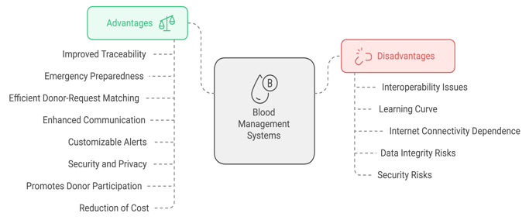Figure 1: Advantage and Disadvantage of Blood Bank Management System

**Challenge of the existing system**

**Inaccuracy in Data:** The traditional record-keeping methods involve mistakes in manual labor or erroneous data input. These errors can build up over time, to the point that it is infeasible to keep track of blood donations, donor information, and stock information accurately. Inconsistent data is one of the greatest hurdles for reporting and decision making which, in turn, is resulting in inappropriate blood supply management risks.

**Delayed Responses:** It is a matter of great urgency that the time needed to identify appropriate blood donors/units during emergencies is maximized. The present system of searching the records, contacting prospective donors, and working out the delivery is, in general, slow, and inefficient. These delays could cause people to die or become ill due to the unavailability of an appropriate sort of blood.

**Limited Accessibility:** Blood donation and storage facilities are typically located in urban settings, and the geographic dispersion of these facilities in rural and remote communities can pose barriers to blood bank access. Coordination for the delivery of blood to these underserved areas is further complicated by the fact that blood cannot be moved excessively quickly to these areas, especially during emergencies, when moments make a difference in the loss of a limb.

**Inefficiency:** The current system is very much based on physical presence, telephone, and manual arrangement, which are all slow and inefficient. This reliance on inefficient techniques is a factor in higher error rates, further delays, and lost opportunities that, in turn, impact the entire efficacy of the blood donation and distribution chain.

**Safety Concerns:** To preserve safety, it is paramount to maintain the health of blood donors and the correct storage of blood units. Yet, the existing system frequently fails to provide standardized, more robust guidelines for confirming donor viability and for blood storage and transportation according to the correct conditions. This discrepancy does create a potential risk of contamination thus jeopardizing the whole safety of the blood supply.

**Key Components of the Existing System:**

**Manual record keeping:** Blood banks rely on paper-based systems to maintain donor information, blood group information, and inventory records. These records are prone to human error, inconsistencies, and misuse, making it difficult to ensure their accuracy and reliability over time.

**Physical arrangements for donors:** During the blood drive, donors are contacted by hand or by phone. This practice can result in significant delays in donating and mobilizing blood in an emergency, with potential risks for patients in critical blood need

**Local availability:** Information on blood availability is limited to individual hospitals or blood banks. Requesters must make multiple phone calls or physically visit multiple locations to obtain required blood samples, which is inefficient and time-consuming.

**Time-consuming process:** Before donating blood, donors must go to a blood bank or hospital to fill out a form and provide a certificate. Meanwhile, delays are caused by unscheduled meetings of blood requesters and ineffective communication.

**Inadequate infrastructure in rural areas:** Underdeveloped areas often do not have blood banks or organized centers. They rely heavily on informal methods such as word of mouth or social media to recruit donors, which may not always be effective or timely

**Lack of real-time data:** The current system does not provide real-time updates on blood availability. This leads to the waste of unused or scarce blood in emergencies when a specific blood type is urgently needed.

1. **PROPOSED SYSTEM**

**Problem We Aim to Solve**

The healthcare sector, particularly blood banks, encounters significant challenges with resource management and operational efficiency. Blood shortages, mismatched supply chains, and the lack of real-time visibility into blood inventory often leads to delays in emergency scenarios. Manual systems often lead to inefficiencies like overstocking and resource wastage, also facing data security and regulatory challenges. A cloud-based, integrated solution is essential to uphold service delivery standards in healthcare.

**Our Proposal**

We propose a **Software as a Service (SaaS)** platform for blood banks using Amazon Web Services (AWS). This platform offers real-time tracking, better supply chain management, and data security. It helps automate tracking and sends alerts to avoid shortages or wastage. The platform also uses IoT-enabled temperature sensors to secure the storage and transportation of blood units, providing real-time feedback.

1. **Real-time Inventory Management**: We can monitor blood in the inventory continuously and send automatic alerts to prevent shortages or waste.
2. **Data Analytics and Forecasting**: We can analyze the data to predict demand and optimize inventory levels using AWS Timestream and Kinesis.
3. **Enhanced Accessibility**: This cloud-based platform allows blood banks to access information through APIs and dashboards.
4. **IoT Integration**: We can use temperature sensors connected to the Internet of Things (IoT) to ensure blood is stored and transported properly, providing real-time data feedback.

**How AWS Will Help**

#### Integrating AWS offers several benefits to this system. AWS services like Lambda and Auto Scaling help the platform grow as needed during emergencies or busy times. For security, tools like Shield, Secrets Manager, and Cognito protect sensitive healthcare data and comply with HIPAA standards. AWS’s pay-as-you-go pricing and serverless setup cut down on infrastructure and operating costs while keeping performance high. Global access is available through AWS CloudFront and Route 53, which provide fast access for users. Advanced analytics features powered by ElastiCache give stakeholders useful insights for better decision-making, and the flexibility of AWS services allows for easy integration with third-party tools and future growth of the system.

|  |  |
| --- | --- |
| **Benefit** | **Metric** |
| Improved Donor Participation | Donor count |
| Reduction in Blood Wastage | Wastage percentage |
| Faster Response Times | Emergency response time |
| Enhanced Efficiency | Manual task reduction |
| Rural Coverage Expansion | Service reach |
| Infrastructure Cost Savings | IT costs |
| Improved Donor Retention | Repeat donations |
| Error Reduction | Error frequency |
| Data-Driven Planning | Inventory accuracy |

Table 1: Quantitative Benefits with Proposed

**How We Will Make a Difference**

Unlike traditional systems that operate in silos, our SaaS platform is fully integrated with cloud-native solutions for managing healthcare resources. Our system’s focus on scalability, automation, and security ensures it remains relevant even as the demands on healthcare systems evolve.

**Why We Chose This Approach**

This approach provides a scalable and reliable healthcare solution using AWS as shown in Figure [2] below. It addresses problems in blood bank operations and helps to improve decision-making, resource management, and collaboration with cohesive cloud infrastructure as a better choice than outdated manual methods.

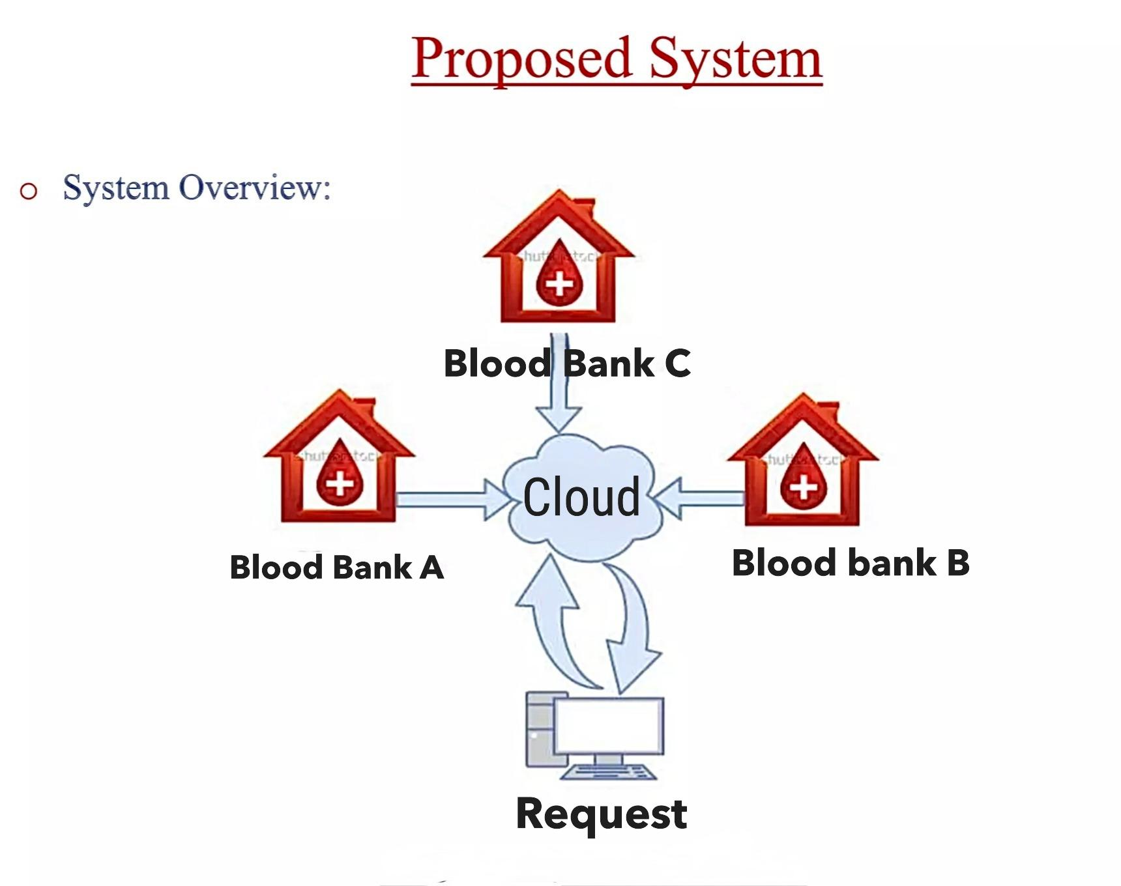Figure 2: Proposed System of Blood Bank Management System

**4. METHODOLOGY**

The Online Blood Bank Management System utilizes a robust, cloud-based architecture leveraging Amazon Web Services (AWS). This methodology outlines the components, their interactions, and their roles in ensuring a scalable, secure, and efficient system.

**1. Architecture Overview**

The system's architecture integrates the following components:

* Frontend Interface: Web and mobile applications for donors, patients, and blood banks to access and interact with the platform.
* Backend Infrastructure: AWS services handle data processing, storage, and security.
* IoT Integration: Real-time monitoring of blood storage conditions using IoT devices.
* Analytics and Reporting: Tools for data-driven decision-making and inventory optimization.

**2. Cloud Infrastructure Components**

The AWS ecosystem provides a robust framework for the system, with the following key components:

**1. DNS and Content Delivery**:

**Route 53:**

Acts as a scalable Domain Name System (DNS) to route users to the Blood Bank System's web application efficiently. Provides custom domain resolution for the platform (e.g., www.onlinebloodbank.com), ensuring low latency and available connections.

**CloudFront:**  
AWS’s Content Delivery Network (CDN) delivers static assets such as images, CSS, and JavaScript quickly to users. Accelerates the user experience for static content on the web interface by caching content in edge locations near users globally.

**2. Compute Layer:**

**EC2 (Elastic Compute Cloud):**

Runs custom application components or legacy services for the platform. Hosts specific workloads, such as scheduling algorithms for donation appointments or processing reports.

**Lambda:**  
Executes backend business logic in a serverless manner. Processes core backend functionalities such as donor registration, blood availability queries, notifications, and transactional processing.

**3. Core Frontend:**

**API Gateway:**

Serves as an entry point for RESTful or Graph-QL APIs. It handles communication between users (mobile apps or web clients) and backend services, such as blood donation requests or blood bank availability searches.

**Location Service:**  
Provides geospatial data for locating blood banks and donors. Enables users to find nearby blood banks or donor locations and integrates mapping for directions.

**4. Backend Processing and Data:**

**RDS:**

Manage relational database for structured data storage. Stores data such as blood bank inventories, user details and appointment schedules with support for complex queries.

**Dynamo DB:**

NoSQL databases for fast and scalable data storage. Maintains real-time data, such as donor availability or blood stock levels, where low-latency performance is critical.

**SQS:**

Asynchronous message queue for decoupled communication. Processes queued tasks like email notifications, SMS alerts for donation requests, or bloodstock updates.

**IoT Core:**

Manages and processes data from IoT devices, such as temperature sensors. Blood banks often need to monitor the temperature of stored blood to ensure safety and compliance. IoT Core real-time monitoring of temperature data from connected sensors in blood storage units. Alerts can be generated if temperature thresholds are breached.

**Timestream:**

Optimized database for storing and analyzing time-series data. Stores time-stamped temperature readings from IoT Core, enabling blood banks to track historical temperature data for compliance reports or trend analysis. It supports efficient querying and visualization of sensor data.

**5. Real-Time and Caching:**

**Kinesis:**

Real-time data streaming. Captures and processes live data, such as donor check-ins, donation statuses, and blood requests.

**ElastiCache:**

In-memory caching for faster data retrieval. Caches frequently accessed data such as user profiles, donor locations, or blood bank inventory, reducing the load on databases.

**6. Security:**

**WAF (Web Application Firewall)**

Protects against common web exploits and DDoS attacks. Ensures the blood bank platform is secure from threats such as SQL injection or XSS.

**Shield:**

Provides DDoS protection. Prevents service disruption caused by DDoS attacks, ensuring platform availability.

**Cognito:**

Manages user authentication and authorization. Provides secure login for donors, blood bank staff, and administrators, with support for identity federation and multi-factor authentication.

**Secrets Manager:**

Safeguards credentials, API keys, and other sensitive data. Manages database credentials or API tokens securely.

**KMS (Key Management Service)**

Encryption for data at rest and in transit. Encrypts sensitive data, such as donor information and bloodstock records, for compliance and security.

**CloudTrail:**

Tracks API calls and resource changes for auditing. Maintains a log of all operations for regulatory compliance and debugging.

**7. Monitoring and Optimization**

**CloudWatch:**

Monitoring and observability for resource and application logs. Tracks key metrics like API response times, database performance, or Lambda execution errors, ensuring platform reliability.

**SNS (Simple Notification Service):**

Sends notification via email or SMS. Alerts administrators about critical events, such as low bloodstock or system failures.

**8. Scalability**

**Auto Scaling Group:**

Dynamically scales EC2 instances. Automatically adjusts computer capacity during peak traffic, such as during emergencies or blood donation drives.

**Elastic Load Balancer (ELB):**

Distributes incoming traffic across multiple instances. Ensures high availability and fault tolerance for user requests.

**9. Cost Optimization**

**Cost Explorer:**

Visualizes cloud spending patterns. Tracks spending on resources like EC2 or RDS to optimize costs.

**Budgets:**

Sets and monitors budget limits. Prevents unexpected overspending by setting alerts for resource costs.

**Reserved Capacity:**

Saves costs on predictable workloads. Reduces expenses for consistently used resources like RDS or EC2 by committing to reserved instances.

Figure 3: Architecture Diagram

|  |  |  |
| --- | --- | --- |
| **Service** | **Usage** | **Cost Estimate (per month)** |
| **Route 53** | 1 hosted zone, 1M queries | $1–$5 |
| **CloudFront** | 500GB data transfer, 5M requests | $10–$100 |
| **EC2** | 2 x t3.medium (24/7) | $74 |
| **API Gateway** | 1M API calls | $10 |
| **Lambda** | 1M requests, 128MB, 100ms avg | $5–$50 |
| **DynamoDB** | 25GB storage, 50 RCU & WCU | $40 |
| **RDS** | 1 x db.t3.medium, 100GB storage | $113 |
| **ElastiCache** | 1 x cache.t3.medium | $61 |
| **IoT Core** | 1M messages | $5–$20 |
| **Kinesis** | 1 shard, 1M records | $50–$100 |
| **CloudWatch** | 10GB logs, 100 custom metrics | $10–$50 |
| **Timestream** | 10GB storage, 1M writes | $10–$50 |
| **CloudTrail** | 1 trail, 10GB storage | $2–$10 |
| **Secrets Manager** | 10 secrets | $4 |
| **S3** | 500GB storage, 1M requests | $10–$100 |
| **Elastic Load Balancer** | 500GB transfer | $36 |
| **SNS** | 100,000 messages | $1–$5 |

Table 2: Estimated Monthly Cost Summary using AWS Cost Explorer

**3. Real-Time Features**

* **Donor Tracking**: GPS-enabled features help patients locate nearby donors during emergencies.
* **Inventory Monitoring**: Tracks blood availability and issues automated alerts for shortages or impending expirations.
* **IoT Alerts**: Generates notifications if storage conditions deviate from the safe range.

**4. Workflow of the System**

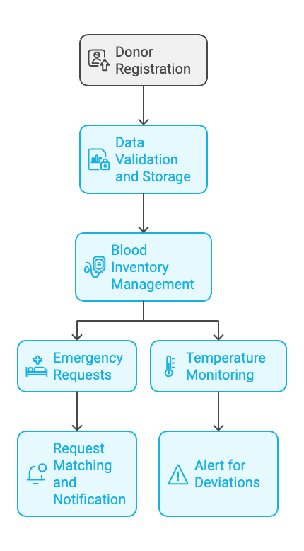Figure 4: Workflow of the Blood Bank System

1. **Donor Registration**:

* Donors register via the web or mobile app, providing details such as blood type and availability.
* Data is validated and stored securely in the database.

1. **Blood Inventory Management**:

* Blood banks update inventory in real time.
* The system predicts potential shortages based on historical trends and demand forecasts.

1. **Emergency Requests**:

* Patients or hospitals can submit blood requests through the platform.
* The system matches requests with available blood units and notifies relevant donors or blood banks.

1. **Temperature Monitoring**:

* IoT-enabled sensors continuously monitor blood storage units.
* Alerts are triggered for deviations, ensuring compliance with safety protocols.

**5. User Experience Enhancements**

* Intuitive interfaces for web and mobile apps ensure ease of use for all stakeholders.
* Interactive dashboards provide stakeholders with insights into donation trends and inventory health.

**6. Implementation Timeline**

|  |  |  |
| --- | --- | --- |
| **Phase** | **Key Activities** | **Deliverables** |
| Initial Planning | Requirement gathering, scope definition | Requirements document, project plan |
| System Design & Architecture | UI design, workflow finalization, AWS architecture | Prototypes, architecture diagrams |
| Core Feature Development | Frontend, backend, database, IoT integration | Functional prototypes |
| Security Integration | Authentication, encryption, compliance checks | Authentication system, compliance report |
| Testing & QA | System and load testing, pilot user feedback | Bug-free system, feedback report |
| Deployment & Rollout | System deployment, user training, awareness | Fully deployed system, training materials |

Table 3: Implementation Timeline

**7. Risk Assessment**

|  |  |  |  |
| --- | --- | --- | --- |
| **Risk Type** | **Specific Risk** | **Impact Level** | **Mitigation Strategy** |
| Technical | System downtime | High | AWS Auto Scaling, CloudWatch monitoring |
| Technical | IoT malfunction | Medium | Regular maintenance, redundant sensors |
| Security | Cyberattacks | High | AWS Shield, MFA, encryption |
| Security | Insider threats | Medium | RBAC, audit logs |
| Operational | Inadequate user training | Medium | Training programs, AI chatbots |
| Operational | Resistance to change | Low to Medium | Stakeholder engagement, pilot programs |
| Financial | Budget overruns | Medium to High | Cost monitoring tools, phased rollout |
| Financial | Maintenance costs | Medium | Budget for maintenance, cost-effective solutions |
| External | Connectivity issues | High | Offline modes, caching with ElastiCache |
| External | Regulatory changes | Medium | Design for quick adjustments, regular compliance audits |

Table 4: Risk assessment

1. **FUTURE WORK**

The Online Blood Bank Management System can significantly enhance its impact and usability by evolving beyond its current functionalities. Future developments could include the following:

1. **Digital Marketing for Blood Donation Events**:  
To boost donor turnout, the platform can leverage digital marketing strategies:

* Implementation: Integrate tools like Google Ads, Facebook, and Instagram APIs for targeted advertising campaigns.
* Targeting Criteria: Personalize campaigns based on user location, historical donation data, and demographic profiles.
* Outreach Strategies: Use email campaigns, push notifications, and SMS to notify users about upcoming events.
* Evaluation Metrics: Employ KPIs such as ad engagement rates, donor registrations per campaign, and event attendance to assess the campaign's effectiveness.

2. **Government Collaboration for Nationwide Integration:**  
Expanding the platform to create a unified, nationwide blood bank network involves:

* Policy Advocacy: Collaborate with health ministries to incorporate blood management systems into national healthcare strategies.
* Data Integration: Link with national health databases for seamless tracking and coordination of blood resources across regions.
* Pilot Programs: Initiate pilot projects in selected cities or regions to demonstrate the system’s effectiveness and scalability.
* Regulatory Compliance: Align the platform with local and international healthcare regulations, such as GDPR or HIPAA.

3. **Patient and Hospital-Centric Services**:  
Improving accessibility for patients and hospitals includes:

* Hospital Access: Provide hospitals with a specialized interface for urgent blood requests and real-time monitoring of nearby blood bank inventories.
* Patient Features: Develop a mobile application module for patients to search for compatible donors, book blood reservations, and access donor statistics.
* Case Study Simulation: Conduct usability tests with hospital staff to ensure the features align with real-world scenarios.

**4. Advanced Analytics and Insights:**

Leverage machine learning to predict blood demand trends, improve inventory efficiency, and reduce wastage.

* Analytics Framework: Implement regression models, clustering algorithms, and time-series analysis to understand seasonal demand variations.
* Integration: Use AWS tools like SageMaker and Quick Sight to process data and provide insights through interactive dashboards.
* Visualization: Develop reports and trend heatmaps for stakeholders to improve decision-making and emergency preparedness.

**5. Integrating AI-Powered Chatbots:**

Enhance user experience with AI-driven support tools:

* Core Features: Integrate chatbots for donor FAQs, real-time blood donation guidance, and emergency assistance.
* Language Models: Utilize GPT-based models for natural language understanding and response generation.
* Scalability: Ensure multilingual capabilities to serve diverse user bases globally.
* Performance Metrics: Measure chatbot efficiency via resolution time and user satisfaction ratings.

**6. Global Expansion and Multilingual Support:**

Addressing global blood shortages requires:

* Localization: Translate the platform into multiple languages and customize it for cultural sensitivities in different regions.
* International Standards: Align with global blood donation protocols like those of WHO and Red Cross.
* Partnerships: Collaborate with international health organizations and NGOs for cross-border blood supply chain management.
* Pilot Tests: Launch in bilingual countries to validate functionality before scaling worldwide.

**7. Gamification to Encourage Donations:**

Incentivizing frequent donors using gamification techniques could increase participation.

* Rewards System: Introduce badges, donation milestones, and redeemable points for active donors.
* Leaderboards: Display donor achievements to encourage community-driven participation.
* Collaboration: Partner with corporate sponsors to offer rewards, such as discounts or gift cards.
* Impact Tracking: Analyze metrics such as donor retention rates and repeat donations to measure effectiveness.

**8. Community-Driven Blood Campaigns:**

Encourage local groups to organize donation drives using community features.

* Group Features: Add modules where users can form or join groups for collective donation efforts.
* Event Scheduling: Allow communities to plan and register events directly on the platform.
* Recognition: Acknowledge active groups with special badges or leaderboard placement.

1. **WORKLOAD ASSIGNMENT**

|  |  |
| --- | --- |
| **Team Member** | **Work Assigned** |
| Ayush Kumar Gupta (Lead) | **Oversee all work, finalize the proposal,** **Research Topic Analysis**, **Methodology**, and **Future Work.** |
| Vidhiben Ashokbhai Vanani | **Literature Review,** **References.** |
| Sai Mani Ritish Upadhyayula | **Proposed System, Contributed to Research Topic Analysis**. |
| Teja Sree Kokkanti | **Abstract and Introduction** |

1. **REFERENCES**

[1] World Health Organization: WHO. (2023c, June 2). Blood safety and availability. <https://www.who.int/news-room/fact-sheets/detail/blood-safety-and-availability>

[2] International Federation of Red Cross and Red Crescent Societies & International Federation of Red Cross and Red Crescent Societies. (2021c). GLOBAL PLAN (International Federation of Red Cross and Red Crescent Societies, Interviewer; By International Federation of Red Cross and Red Crescent Societies).  
<https://www.ifrc.org/sites/default/files/IFRC-2021-Global-Plan-FINAL-1.pdf>

[3] Jansen, N. E., Williment, C., Haase-Kromwijk, B. J. J. M., & Gardiner, D. (2022b). Changing to an opt out system for organ Donation—Reflections from England and Netherlands. Transplant International, 35. <https://doi.org/10.3389/ti.2022.10466>

[4] t Mowla, S. J., Sapiano, M. R. P., Jones, J. M., Berger, J. J., & Basavaraju, S. V. (2021). Supplemental findings of the 2019 National Blood Collection and Utilization Survey. Transfusion, 61(S2).  
<https://doi.org/10.1111/trf.16606>

[5] AABB. (2021). Relationship Testing Technical Report 2021.  
<https://www.aabb.org/docs/default-source/default-document-library/accreditation/2021-technical-report-summary.pdf?sfvrsn=b5573dc0_2>

[6] In a 2022 report by the Global Privacy Assembly,

<https://globalprivacyassembly.org/wp-content/uploads/2022/03/PSWG3-Privacy-and-data-protection-as-fundamental-rights-A-narrative-ENGLISH.pdf>

[7] AHP Connect Details. (n.d.). Default. <https://www.ahp.org/resources-and-tools/ahp-connect/ahp-connect-details/effective-donor-retention-in-healthcare-5-strategies-to-improve-engagement-and-support>

[8] The Office of the National Coordinator for Health Information Technology, Department of Health and Human Services, & Tripathi, M. (2022). 2022 Report to Congress: Update on the access, exchange, and use of electronic health information.  
<https://www.healthit.gov/sites/default/files/page/2023-02/2022_ONC_Report_to_Congress.pdf>

[9] Şanal, L., Günaydın, S., & Tatar, M. (2023b). Cost-Effectiveness and budget impact analyses of patient blood management in a cardiovascular surgery department at Ankara Bilkent City Hospital in Turkey. Advances in Therapy, 41(2), 716–729.  
<https://doi.org/10.1007/s12325-023-02733-5>

[10] World Development Report 2021 team. (n.d.). World Development Report 2021: Data for Better Lives | Connecting the world. <https://wdr2021.worldbank.org/stories/connecting-the-world/>

[11] 2022 issues | American Journal of Clinical Pathology | Oxford Academic. (n.d.).

<https://academic.oup.com/ajcp/issue-archive/2022>

[12] Health Sector Cybersecurity Coordination Center (HC3)

<https://www.hhs.gov/sites/default/files/hc3-2022-q4-healthcare-cybersecurity-bulletin-tlpclear.pdf>